**Linear Modeling Feb 7, 2021**

Summary: The plant model verification script Vent_data_match.sce was run on representative plant data. We also had manual data run CoolTerm Capture 2021-01-21 14-12-19.xlsx that is the best look at the duct plant. The duct plant proved impossible, or too complicated, to model. We also get good control result with simple PI compensation where the lead compensation is a 600 second lead. So linear analysis is to confirm good behavior and confirm fairly accurate model.

References:

1. 'vent_2021-02-06T14-00' + ‘.csv’ Data run.
2. CoolTerm Capture 2021-01-21 14-12-19.xlsx Manual data recording of duct step test.
3. Vent_data_match.sce The model executive program
4. heat_model.sce – total_heat() The all-inclusive heat model

Setup:

1. Various data runs in run_name = 'vent_2021-02-06T14-00' + ‘.csv’
2. Construct 2-pole model of room heat transfer in total_model().
3. Vent_data_match.sce runs test data through model.
4. Tune constants in ‘heat_model_constants.sce’ to match data. Also added 360 sec lag on duct flow inline in the total_model() of ‘heat_model.sce’ to match observations of CoolTerm Capture 2021-01-21 14-12-19.xlsx. Ignored the small short term heat soak pole.
5. Add a significant heat leakage feature that always seems to be present Qlk.
6. Another significant modeling feature was to account for observed changes in uncommanded convection int the room when air flow is low. This is a fudge factor that would vary between runs.
7. Evaluate linear model in Vent_data_match and plot the resulting poles.
8. Play with complete open loop system model to evaluate stability and bandwidth.
9. 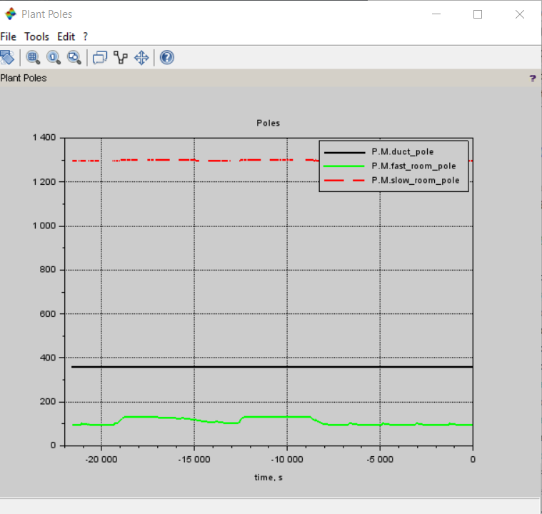
10. This bode plot shows that lead compensation of 600 seconds puts 45 deg of phase lead about where the 45 deg point of the plant is. Not bad for guesswork!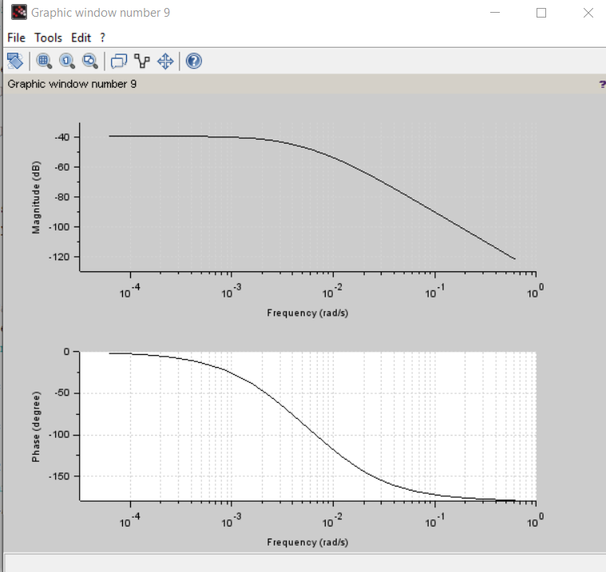

Conclusion:

1. The model poorly represents the system. It would have limited use.
2. The order of the system appears to be about right: 1 large 360 sec duct pole and 2 room poles of about 120 sec and 1300 sec.
3. Numerical results of total system stability cannot be reported due to poor quality of data.

Discussion: This work served nicely to verify a simple plant model. This model may be used for ‘dry rig’ bare processor model use. It could be built into an embedded model for future use. Basic design approach is not out of line with the general observations of the poorly correlating model.